 | Appendix 10
 | FORMAT FOR MANDATORY DISCLOSURE
 | Mandatory Disclosure
10.1 | AICTE File No. |  | WROK-2018712652 (AICTE NO.22)
 | Date & Period of last approval |  | 11 March 2014
10.2 | Name of the Institution |  | Shree Datta Polytechnic College, Dattangar
 | Address of the Institution |  | Po:Dattanagar 416 120, Tal: Shirol Dist:Kolhapur
 | City & Pin Code |  | 416 120
 | State / UT |  | Maharashtra
 | Longitude & Latitude |  | 74,35,21 & 16,45,0
 | Phone number with STD code |  | 02322-237397 & 02322-236551 to 56 (6 Line)
 | FAX number with STD code |  | 02322-236600
 | Office hours at the Institution |  | 10.00 A.M. to 5.30 P.M.
 | Academic hours at the Institution |  | 10.30 A.M. to 5.30 P.M.
 | Email |  | dattapoly@gmail.com
 | Website |  | www.dattapolytechnic.com
 | Nearest Railway Station  (dist in Km) |  | Jaysingpur Railway Station, Jaysingpur (6 km)
 | Nearest Airport (dist in Km) |  | Kolhapur Airport (50 km)
10.3 | Type of Institution |  | Private-Self Financed
 | Category (1) of the Institution |  | Non Minority / Minority specify minority :
 | Category (2) of the Institution |  | Co-Ed / Women only
10.4 | Name of the organization running the Institution |  | Shree Datta Shetkari Sahakari Sakhar Karkhana Ltd Charitable Trust’s  Shree Datta Polytechnic College, Dattangar.

 | Type of the organization | Trust
 | Address of the organization | Po: Dattanagar 416 120, Tal : Shirol Dist : Kolhapur
 | Registered with | Trust Act.
 | Registration date | 21/06/2007
 | Website of the organization | www.dattasugar.org
10.5 | Name of the affiliating Board | MSBTE, Mumbai
 | Address | Government Polytechnic,4th floor ,49, Kherwadi, Bandra (E), Mumbai-400 051.  Email ID: secretary@msbte.com  Phone Numbers : 91-022-26471255, 26472122, 26475077, 26478296  Fax: 91-022-26473980, 26473979
 | Website | www.msbte.com
 | Latest affiliation period | 2013-14
10.6 | Name of Principal | Mr. Rajendra Savanta Chougule
 | Exact Designation | I/C Principal
 | Phone number with STD code | 02322 / 237397, 9372617477
 | FAX number with STD code | 02322 - 236600
 | Email | dattapoly@gmail.com
 | Highest Degree | B.E (E&TC), M.E. Appearing
 | Field of specialization | ELECTRONICS
10.7 | Governing Board Members | List Attach
 | Frequency of meetings & date of last meeting | 02/07/2014
10.8 | Academic Advisory Body | List Attach
 | Frequency of meetings & date of last meeting
10.9 | Organizational Chart | Attach

10.10 | Student feedback mechanism on Institutional Governance/faculty performance | Good
10.11 | Grievance redressal mechanism for faculty, staff and students | Nil
10.12 | Name of the Department* | ME CE EJ CO EE
 | Course | Diploma
 | Level | UG
 | 1st Year of approval by the Council | 2010
 | Year wise Sanctioned Intake | 2010 – 300, 2011 – 315, 2012- 420, 2013- 420
 | Year wise Actual Admissions | 2010 – 290, 2011 – 315, 2012- 354, 2013- 328
 | Cut off marks – General quota | 245/600 (40.83%)
 | % Students passed with Distinction | 10 %
 | % Students passed with First Class | 65 %
 | Students Placed | 26
 | Average Pay package, Rs. /Year
 | Students opted for Higher Studies | 119
 | Accreditation Status of the course | Not eligible yet
 | Doctoral Courses | - Yes / No
 | Foreign Collaborations, if any | No
 | Professional Society Memberships | Nil
 | Professional activities | Nil
 | Consultancy activities | Nil
 | Grants fetched | Nil
 | Departmental Achievements | Nil
 | Distinguished Alumni | NA
10.13 | Faculty Data Attach
10.14 | Admission quota# | Cap – 80% , Institute Level 20%
 | Entrance test / admission criteria | S.S.C. pass with 35%
 | Cut off / last candidate admitted | 245/600 (40.83%)
 | Fees in rupees | 43000/-
 | Number of Fee Waivers offered | 21
 | Admission Calendar | 08/07/2013 to 10/08/2013
 | PIO quota | Nil

10.15 | Infrastructural information^
1. | Classroom/Tutorial Room facilities

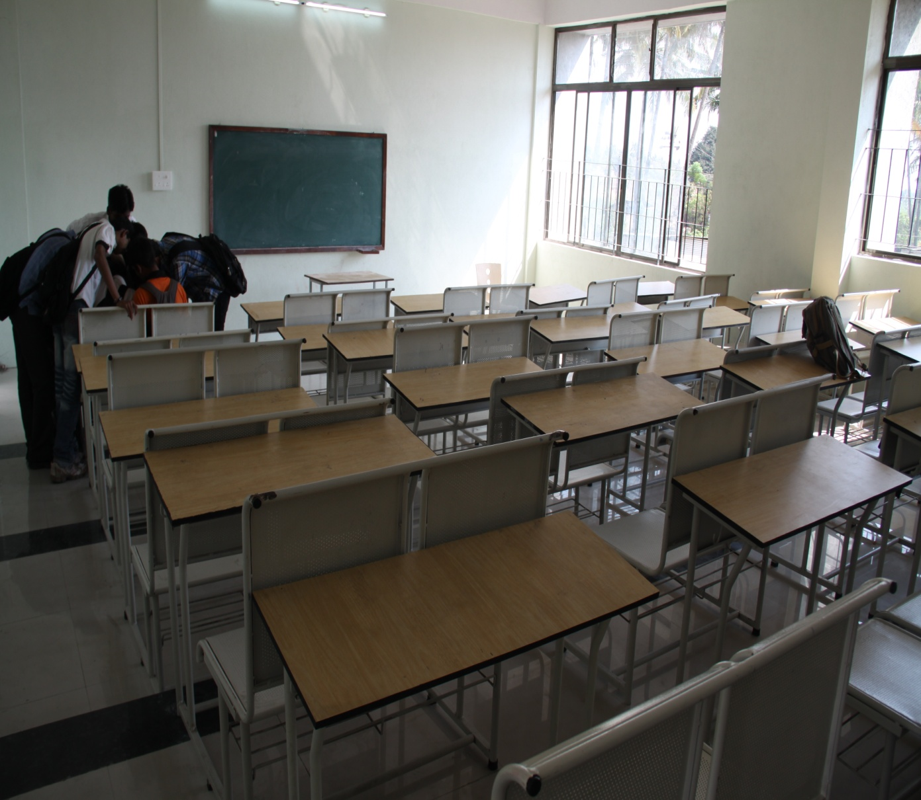
2. | LABORATORY DETAILS
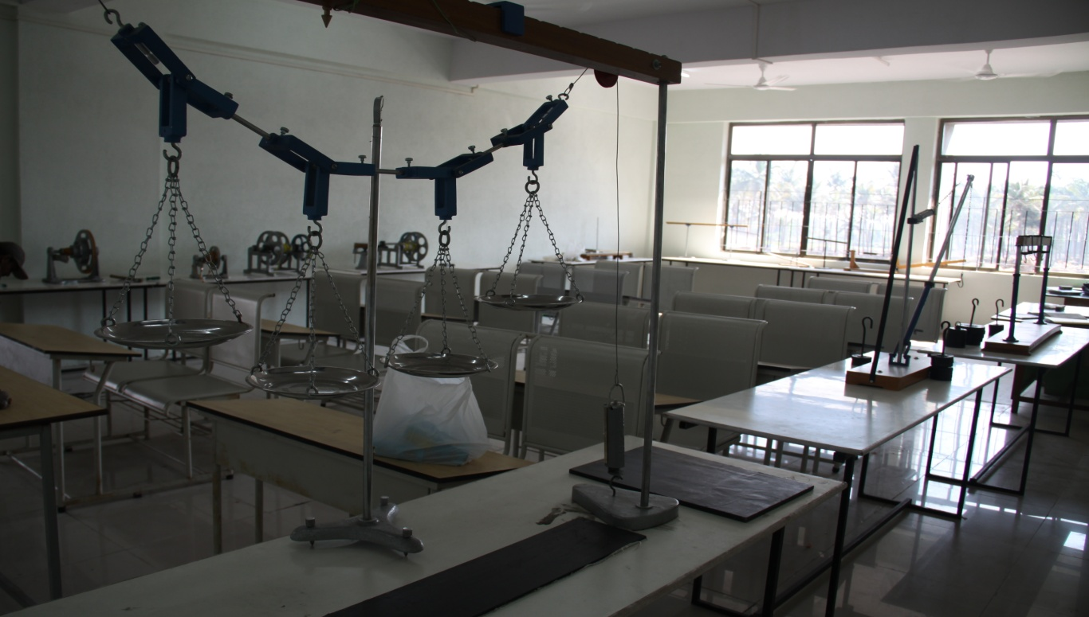

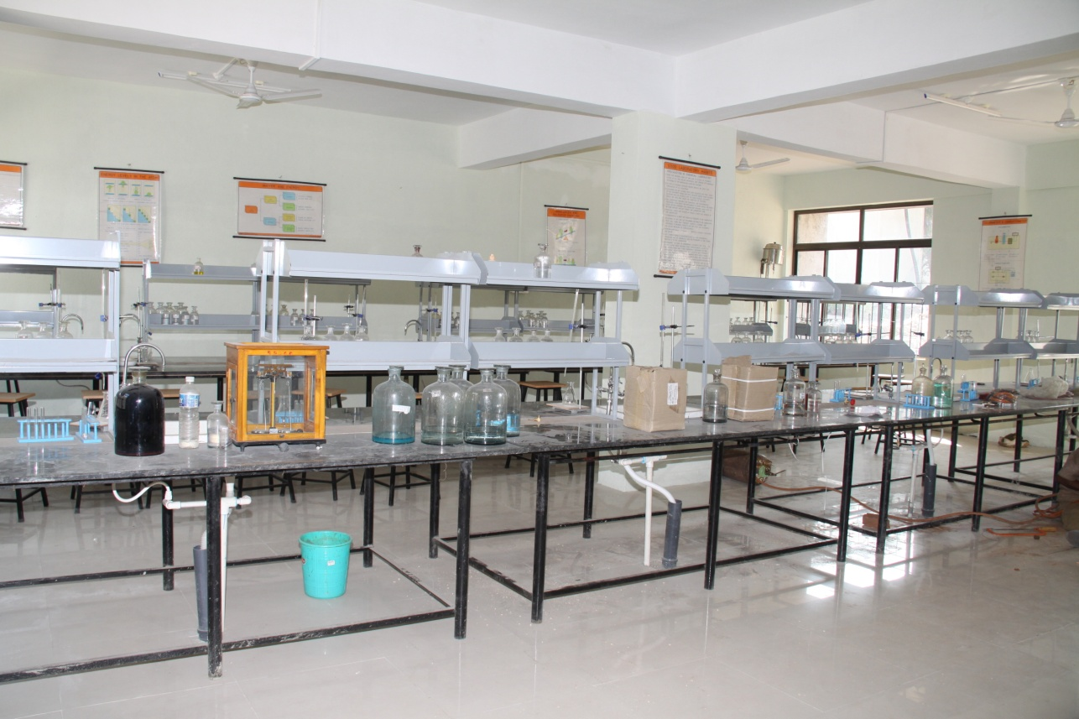
3. | COMPUTER CENTRE FACILITIES

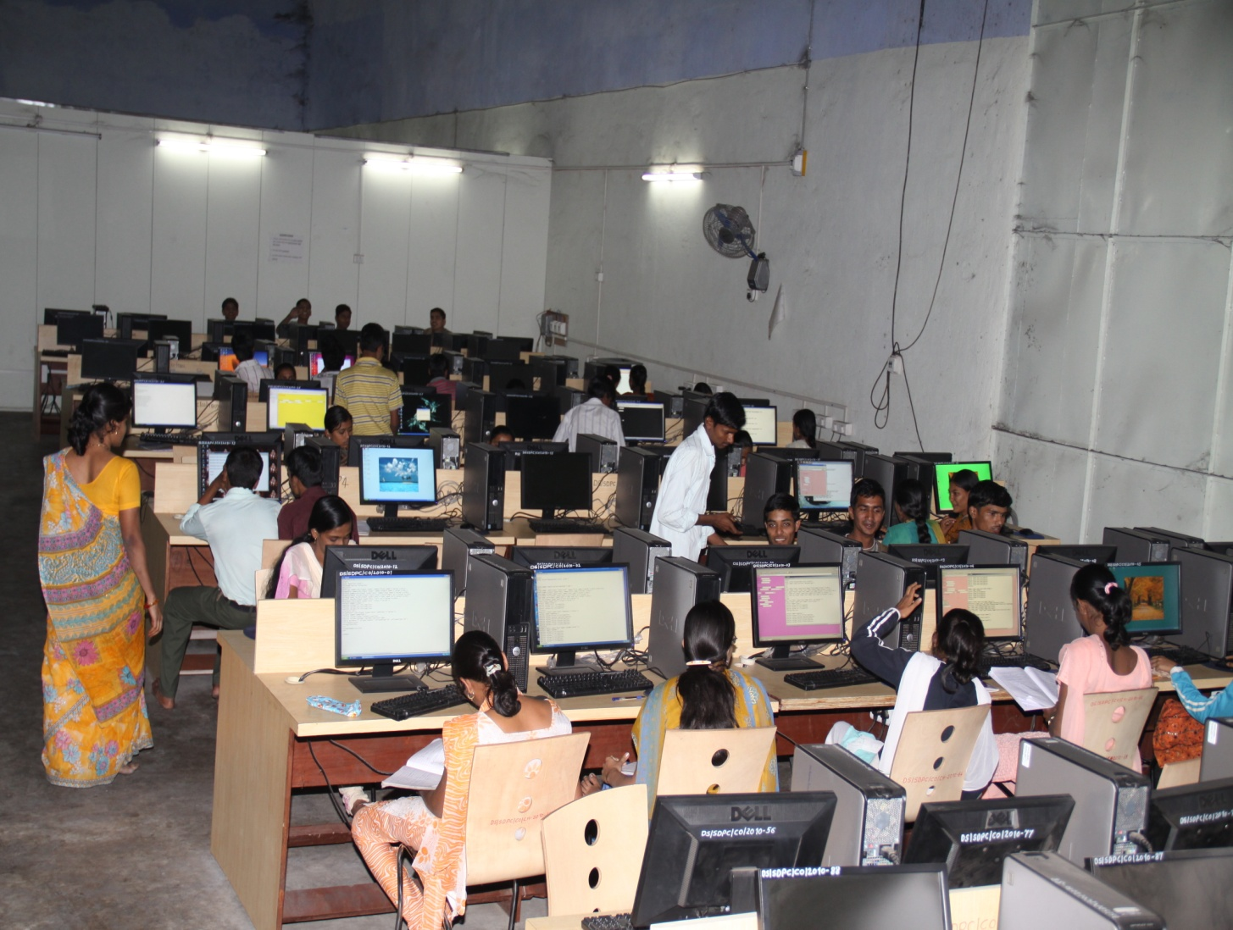
4. | LIBRARY FACILITIES
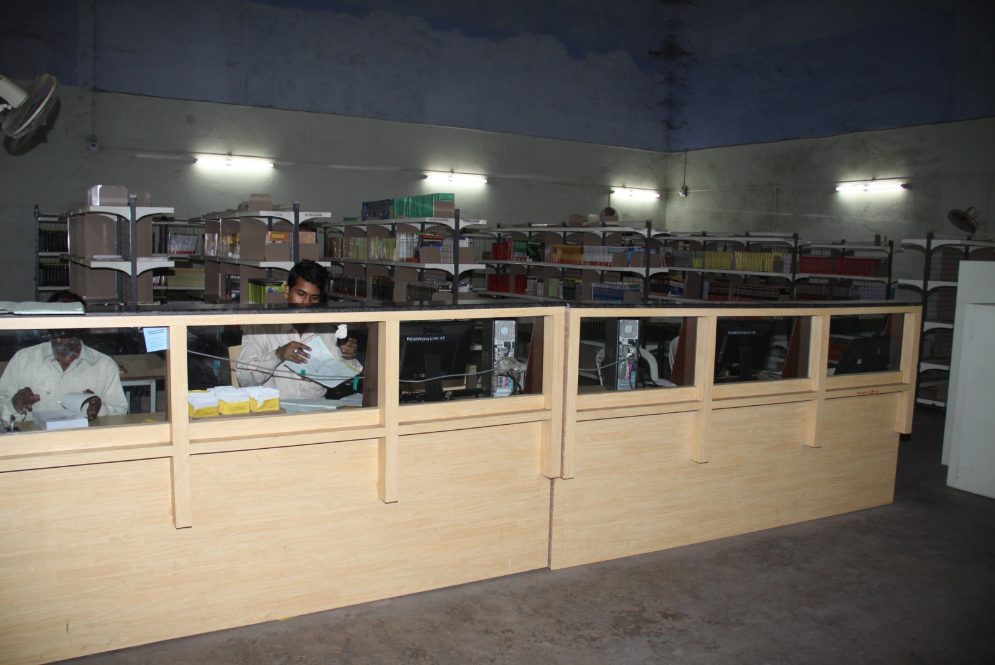
5. | SEMINAR HALLS

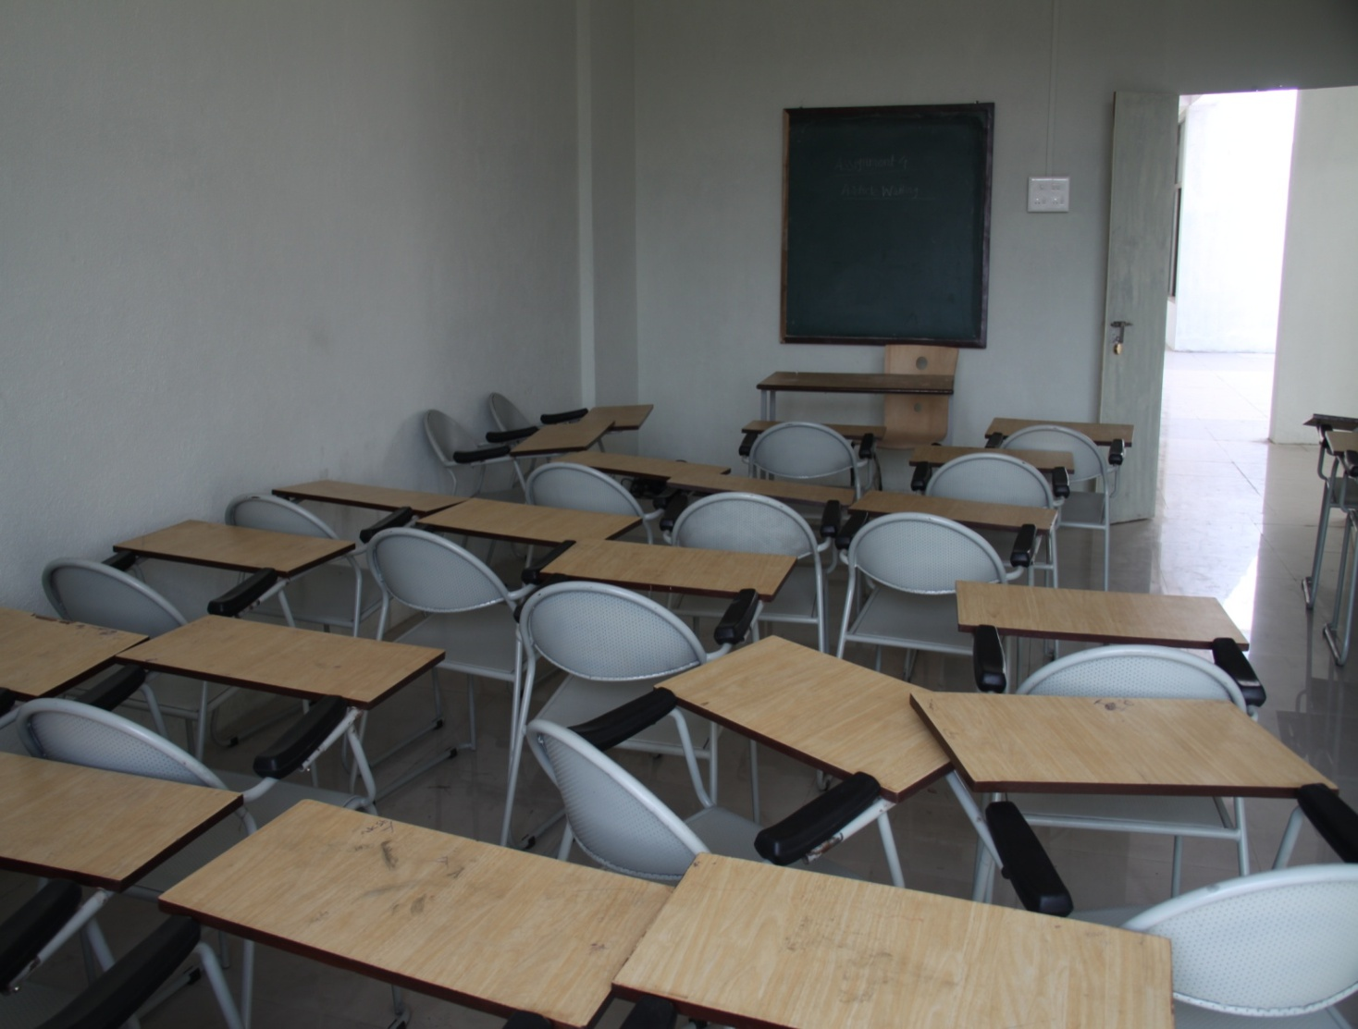
5. | INDOOR SPORTS FACILITIES

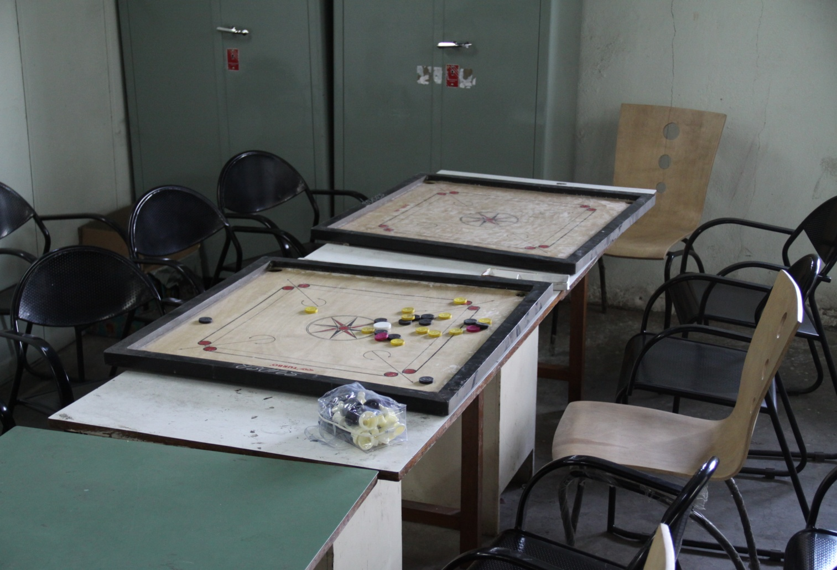
6. | OUTDOOR SPORTS FACILITIES

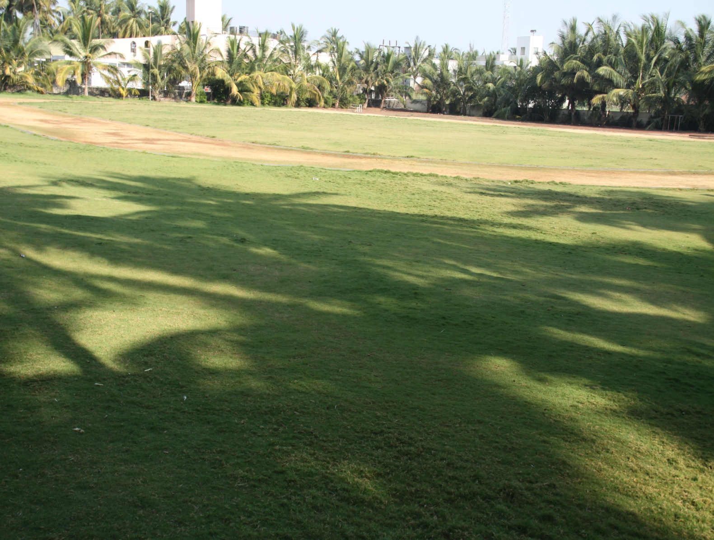  7. | Gymnasium facilities | No

8. | Facilities for disabled | No

10. | ANY OTHER FACILITIES

Post Office
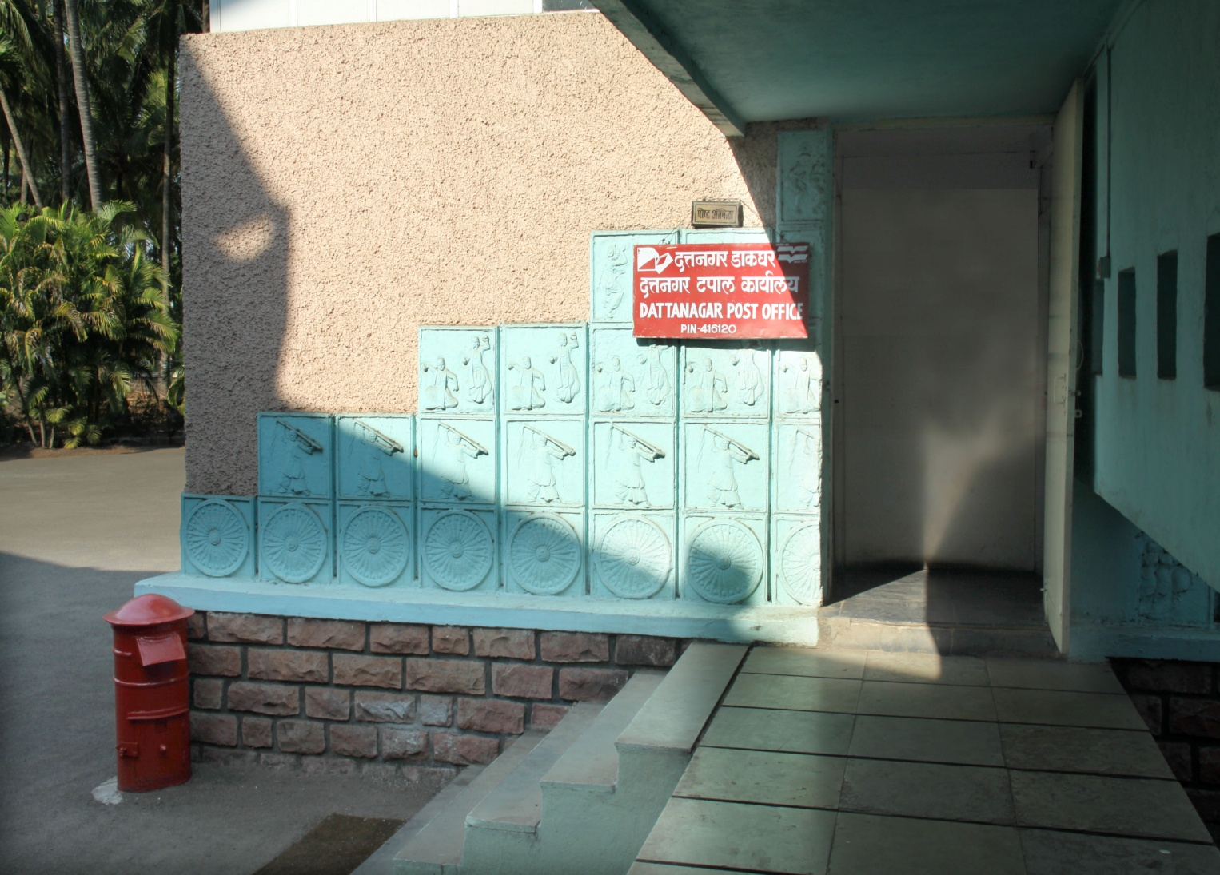
10.16 | Boys Hostel | No

9. | GIRLS HOSTEL

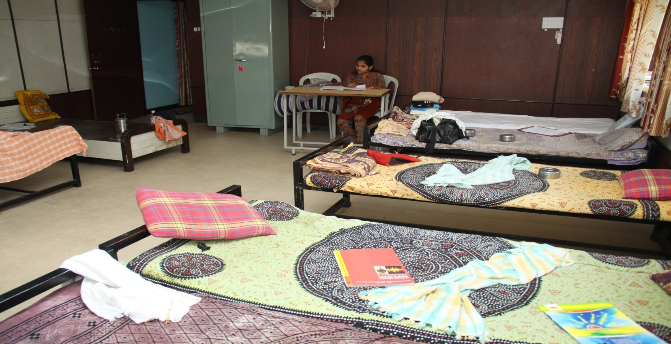
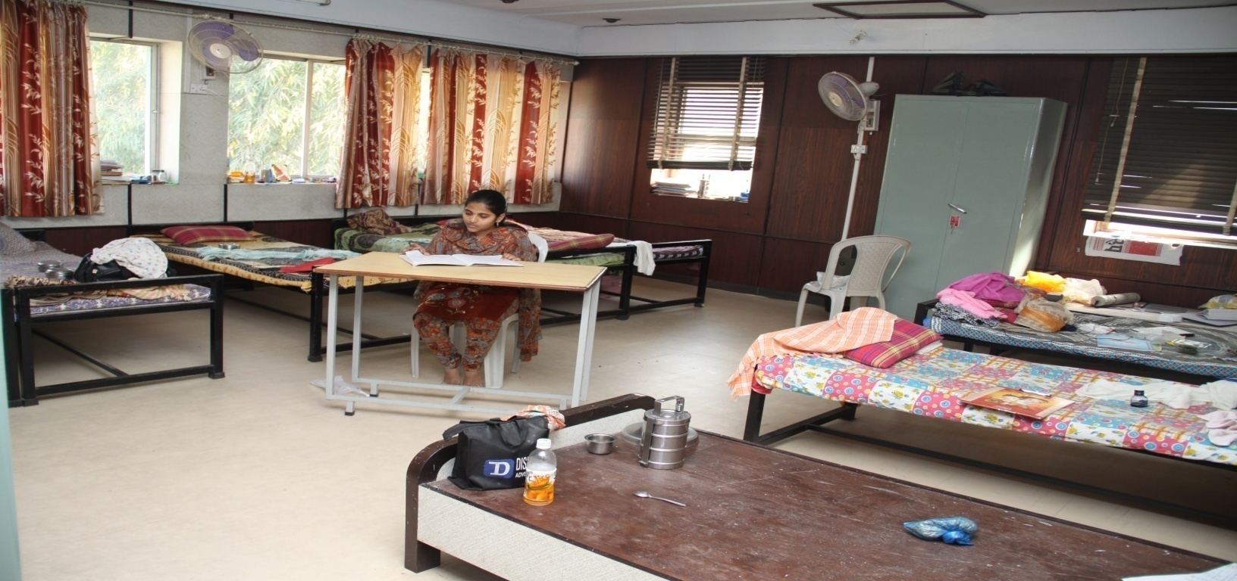
10. | BOY’S HOSTEL

3. | MEDICAL & OTHER FACILITIES AT HOSTEL

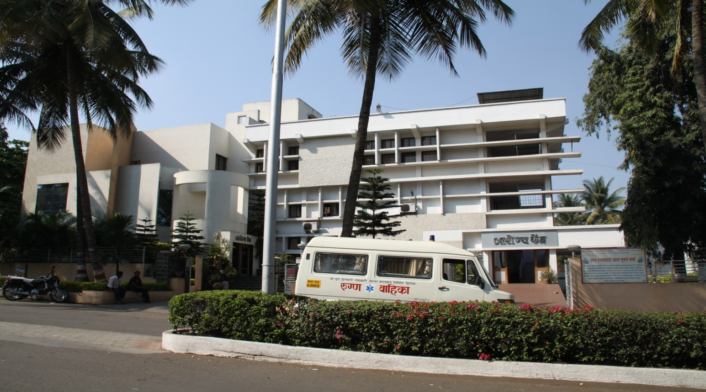
Canteen
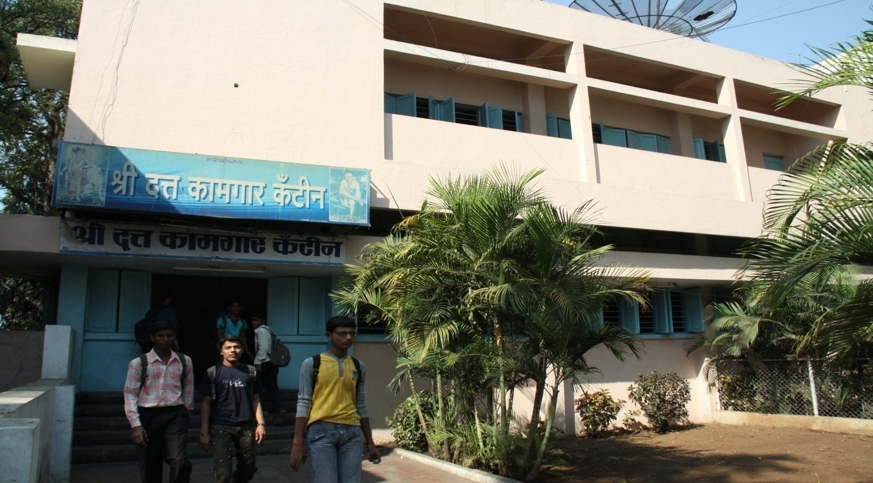
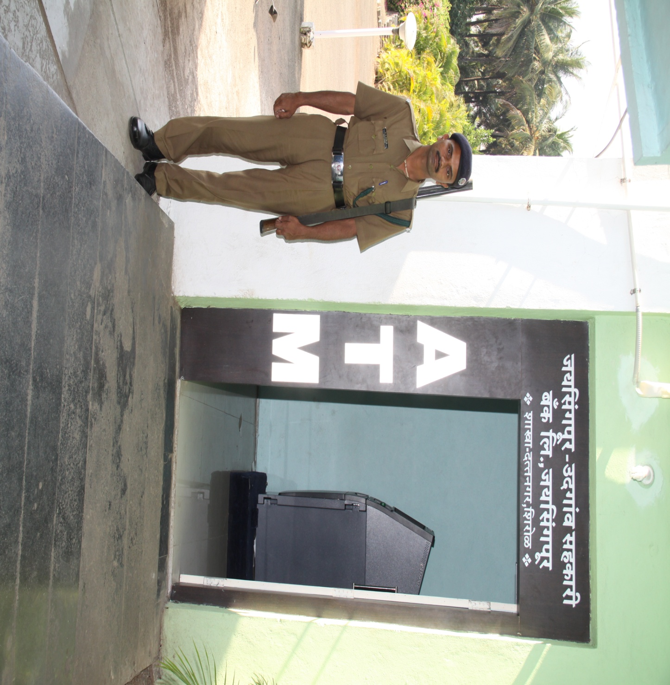
ATM

10.17 | Academic Sessions
 | Examination system, Sem | SEM
 | Period of declaration of results | February & June
10.18 | Counseling / Mentoring | Mentoring
 | Career Counseling | Yes
 | Medical facilities | Yes
 | Student Insurance | NO
10.19 | Students Activity Body
 | Cultural activities | YES
 | Sports activities | YES
 | Literary activities | YES
 | Magazine / Newsletter | YES
 | Technical activities / Tech Fest | YES
 | Industrial Visits / Tours | YES
 | Alumni activities | NA
10.20 | Name of the Information Officer for RTI | Prof. Rajendra Savanta Chougule
 | Designation | Principal
 | Phone number with STD code | 02322-237397
 | FAX number with STD code | 02322-236600
 | Email | dattapoly@gmail.com

